Parallel Interface and 8255 PPI
A Parallel Interface is used for transmitting multiple data signals simultaneously over several parallel channels. In essence, multiple bits (typically 8) are transmitted at the same time on different channels within the same cable.
They are also commonly used within ICs, peripheral buses, and memory devices like RAM.
Benefits or Advantages of Parallel Interface
The primary advantage of a parallel interface is its speed.
- It offers faster data communication between devices compared to serial interfaces.
Drawbacks or Disadvantages of Parallel Interface
Despite its speed, the parallel interface has some limitations.
- It supports short-distance communication between devices. This limitation arises from crosstalk between the parallel lines.
- It uses more wires compared to a serial interface, making it more costly and somewhat more complex to implement.

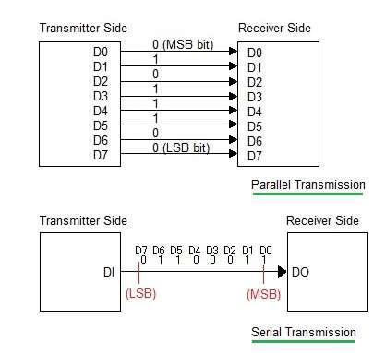

Modes of Parallel Data Transfer
i) Simple I/O
• When you need to get digital data from simple switch, such as thermostat, into microprocessor, all you have to do is connect the switch to an I/O port line and read the port.
• Likewise, when you need to output data to simple display device, such as LED, all you have to do is connect the input of the LED buffer on an output port pin and output the logical level required to turn on the light.
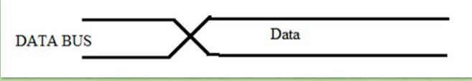
Fig: Simple I/O

iI) Strobe I/O
• In many applications, valid data is present on an external device only at a certain time, so it must be read in at that time.
• E.g. the ASCII-encoded keyboard. When a key is pressed, circuitry on the keyboard sends out the ASCII code for the pressed key on eight parallel data lines, and then sends out a strobe signal on another line to indicate that valid data is present on the eight data lines.
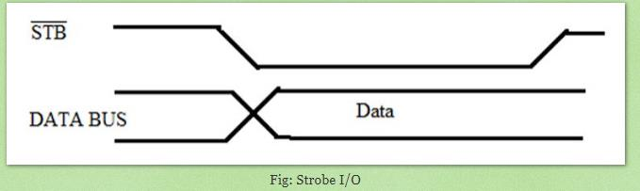

The sending device, such as a keyboard, outputs a parallel data on the data lines, and then outputs an STB signal to let you know that valid data is present.
• For low rates of data transfer, such as from a keyboard to a MP, a simple strobe transfer works well.
• However, for higher speed data transfer, this method does not work because there is no signal which tells the sending device when it is safe to send the next data byte.
• In other words, the sending system might send data bytes faster than the receiving system could read them.
• To prevent this problem, a handshake data transfer scheme is used.
iii. Single handshake
• The peripheral outputs some parallel data and sends an STB signal to the MP.
• The MP detects the asserted STB signal on a polled or interrupts basis and reads in the bytes of data.
• Then, the MP sends ACK (acknowledge) signal to the peripheral to indicate that the data has been read and that the peripheral can send next byte of data.
• The point of this method is that the sending device or system is designed so that it does not send the next byte until the receiving device or system indicates with an ACK signal that it is ready to receive the next byte.

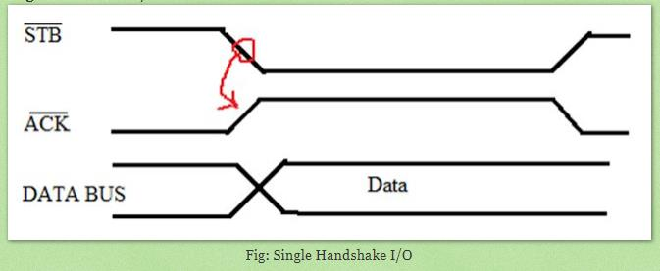

iv. Double Handshake
• For data transfer where even more coordination is required between the sending system and the receiving system, a double handshake is used.
• The sending (peripheral) device asserts its STB line low to ask the receiving device whether it is ready or not for data reception.
• The receiving system raises its ACK line high to indicate that it is ready.
• The peripheral device then sends the byte of data and raises its STB line high to assure that the valid data is avaielable for the receiving device (MP).
• When MP reads the data, it drops its ACK line low to indicate that it has received the data and requests the sending system to send next byte of data.
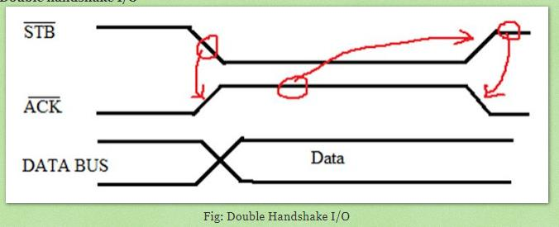

Explain the block diagram of 8255 PPI.
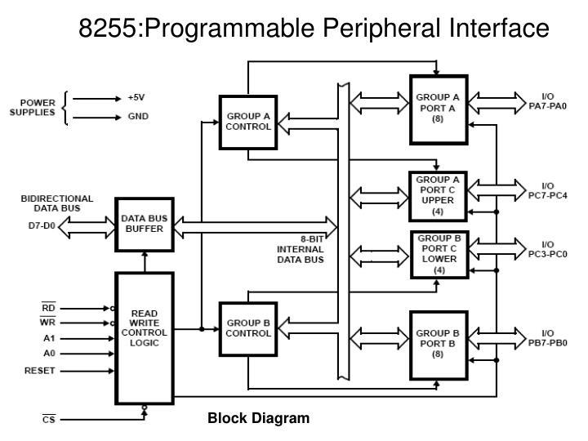
Figure shows the internal block diagram of 8255A. It consists of data bus buffer, control logic and Group A and Group B controls.
- Data Bus Buffer: This tri-state bi-directional buffer is used to interface the internal data lilts of 8255 to the system data bus. Input or Output instructions executed by the CPU either Read date from or Write data into the buffer. Output data from the CPU to the ports or control register, and input data to the CPU from the ports or status register are all passed through the buffer.
- Group A and Group B Controls: Each of the Group A and Group B control blocks receives control words from the CPU and issues appropriate commands to the ports associated with it. The Group A control block controls Port A and PC7-PC4 while the Group B control block controls Port B and PC3-PC0.
- Port A: This has an 8-bit latched and buffered output and an 8-bit input latch. It can be programmed in three modes: mode 0, mode 1 and mode 2.
- Port B: This has an 8-bit data I/O latch/ buffer and an 8-bit data input buffer. It can be programmed in mode 0 and mode 1.
- Port C: This has one 8-bit unlatched input buffer and an 8-bit output latch/buffer. Port C can be spitted into two parts and each can be used as control signals for ports A and B in the handshake mode. It can be programmed for bit set/reset operation.
- Read Write Control Logic:
• This is getting the input signals from control bus and Address bus
• Control signal are RD and WR.
• Address signals are A0, A1 and $\overline{CS}$.
• 8255 operation is enabled or disabled by $\overline{CS}$.
• RESET: This is used to reset the device. That means clear control registers.
Port Selection:
Address lines A0, A1 and Chip Select ($\overline{CS}$) used in various port selection as :
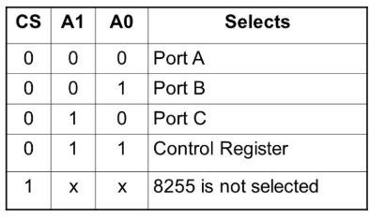

QNS: Explain different operating modes in 8255 PPI.
8255- PPI Modes of operation

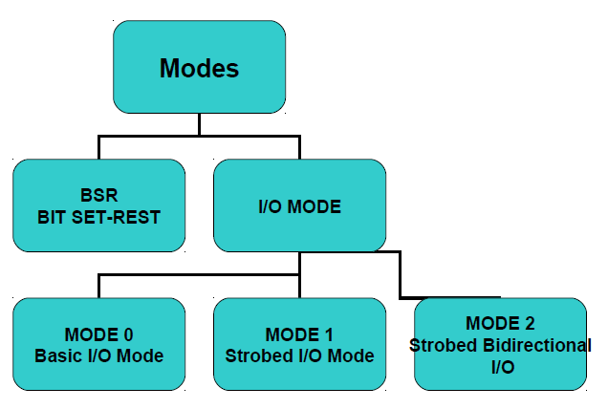

Remember: These modes are achieved in 8255 PPI by writing appropriate bits in the CONTROL REGISTER.

BIT Set Reset Mode (BSR Mode)
• The PORT C can be Set or Reset by sending OUT instruction to the CONTROL registers.
• The control word format for the BSR mode is shown.

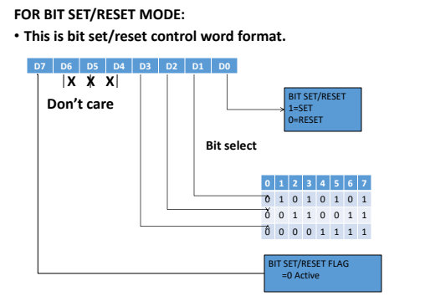

Input/output mode (I/O)
Feature | Mode 0 (Simple I/O) | Mode 1 (Strobed I/O) | Mode 2 (Bidirectional I/O)
Operation | Basic data transfer without any status check or synchronization. | Strobed data transfer where the peripheral and CPU "agree" when to send/receive. | High-speed bidirectional communication on a single 8-bit bus.
Input Status | Not Latched (Buffered only). | Latched (Internal register holds data until read). | Latched.
Output Status | Latched. | Latched. | Latched.
Handshaking | None used. | Used. Uses 3 pins of Port C per port (A or B). | Used. Uses 5 pins of Port C for Port A only.
Application | LEDs, simple switches, 7-segment displays. | Printers (Output), Keyboards (Input), A/D Converters. | Inter-CPU communication, Floppy Disk Controllers.
Interrupt | No. | Yes (Supports interrupt-driven I/O). | Yes (Supports interrupt-driven I/O).

